**Experiment No :** 22

**Experiment name :** Write a C program to swap two numbers without third variable

**Methodology :**

In this program, we first read two numbers (num1 and num2) from the user. Then, we print their values before swapping. To swap the numbers without using a third variable

**Flow-Chart :**

int x , y ;

scanf("%d %d",&x , &y);

**Code :**

x = x + y ;

y = x - y ;

x = x - y ;

printf("\nAfter swapping the valu of x & y : %d %d " ,x , y);

#include<stdio.h>

int main()

{

int x , y ;

printf("Input valu of x & y : ");

scanf("%d %d",&x , &y);

printf("\nBefore swapping the value of x & y : %d %d", x, y);

x = x + y ;

y = x - y ;

x = x - y ;

printf("\nAfter swapping the valu of x & y : %d %d " ,x , y);

return 0 ;

}

**Output:**

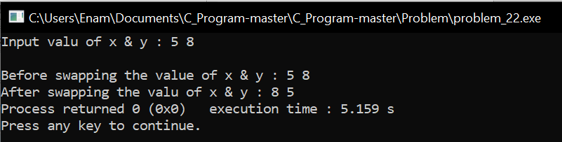

**Result discussion :**

1. Add num1 and num2 and store the result in num1.
2. Subtract the new value of num2 from the updated num1 and store the result in num2.
3. Finally, subtract the new value of num2 from the updated num1 and store the result in num1.
4. After these operations, the values of num1 and num2 will be swapped. We then print the values of num1 and num2 after the swap.